Calculus Based Physics: Lab
PHYS 2110 WA
Date: June 8th 2023
Isaac Abella

Experiment 2
Ohm’s Law

Group:
Isaac Abella

Objective:
The objective was to verify Ohm’s Law through PHET Lab.

Equipment:
A computer with internet access, paper, pencil, calculator (ti84 plus ce/ti 30sx II) , PHET applet

Theory:
Ohm’s law states that the ratio of the voltage across a resistor to the current through that resistor is a constant called the “electric resistance, R” of that resistor.

Denoted as:

V is in volts and I in amps. That makes unit of R to be “volts per amp.” that is called “Ohms”. The symbol for “Ohm” is “Ω”, pronounced: “omega”.

Procedure:
Open PHET Laboratory for circuit construction: https://phet.colorado.edu/sims/html/circuit-construction-kit-dc-virtual-lab/latest/circuit-construction-kit-dc-virtual-lab_en.html

Using the items located in the resource box located on the left side of the screen. Then move the circuit elements to the tabletop (for this lab the tabletop is just the main screen). The values of the items can be selected and changed by double clicking. Then construct a circuit big enough to where the length of the connecting wires in between its elements of a branch is no less than ½ of an inch.

Note, although the PHET applet does not allow for assignment of names to a connection point such as “A, B, C… etc”. All connection points are to be labeled for the creation of the circuit such as the provided figures in the lab manual. Labels such as “I, R, V, A and Vbat” are to be assumed for figures in the same location, order and location.

After the circuit is constructed, assign names to the resistors R and Rheostat, the same as the figure provided below. Note that the golden side of the battery indicates the positive terminal.

From the available tools, turn all available options on and select the conventional direction for current, this means the conventional direction of current is the direction of motion of the positive charges.
Revise this line before submission

From the resource box, use the ammeter and place it between the two named resistors. Then, in the settings tab on the right hand side, go to advanced and change the wire resistivity values to the lowest possible value. (Done by sliding all the way left.)

Note that when going through the lab, do not click on the refresh circular button at the lower right hand side of the screen. This will delete the current circuit built. For the purpose of the lab only use the first circuit system created, not creating a new circuit for each trial.

For reference, here is my setup of the lab:

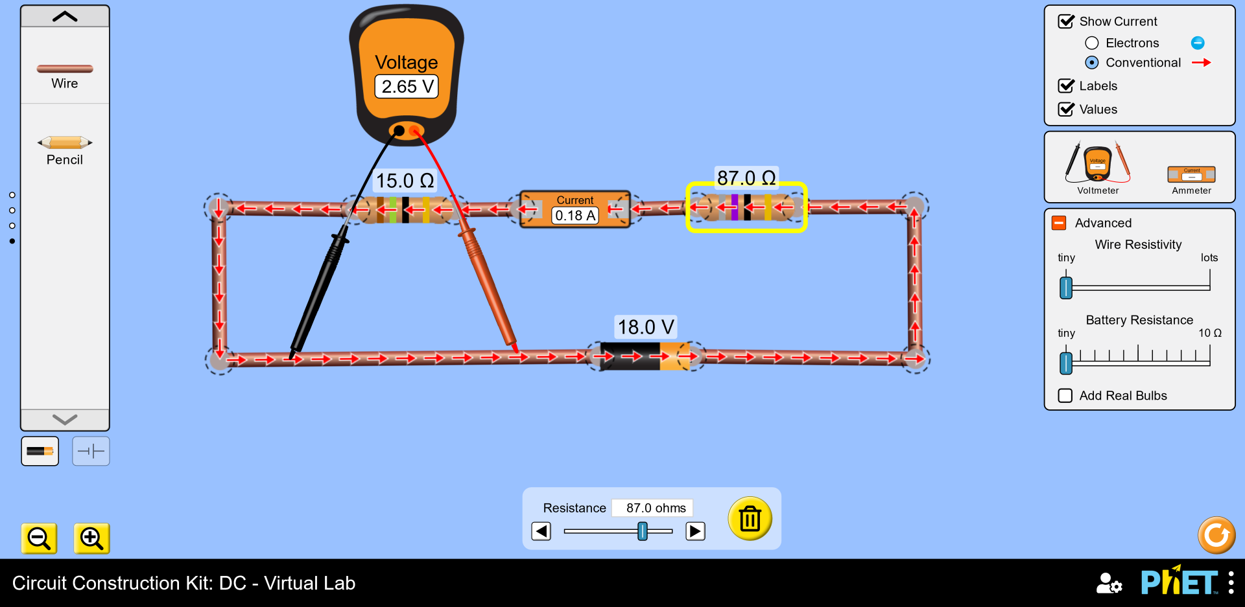
Data:
Given and Measured:

The accepted value for Rs is …..

Trial | Rheostat  Resistance  (Ω) | Voltage V across  Rs  (Volts) | Current I through  Rs  (Amps) | Rs = V/I  (Ω)
1 | 10.0 | 10.8 | 0.72 | 15.0
2 | 13.0 | 9.64 | 0.64 | 15.063
3 | 17.0 | 8.44 | 0.56 | 15.071
4 | 18.0 | 8.18 | 0.55 | 14.873
5 | 34.0 | 5.51 | 0.37 | 14.892
6 | 87.0 | 2.65 | 0.18 | 14.722
 |  |  | Mean Rs: | 14.937

Calculations:
Calculation for Trial 6:

Setting the Rheostat Resistance to 87.0 Volts, the voltmeter measured the resistor R to make 2.65 Volts, and the current flowing the ammeter to be 0.18 Amps. Then applying the Ohms Formula:

The Rs value evaluates to R = 2.65/0.18 = 14.7222… ~ 14.722.

Comparison of The Results
For each case, calculate a percent error only on the mean value of Rs.

Applying the Percent Error Formula:

We get: (15 – 14.937) / (15) X 100 =. 42% Errors

Conclusion
The objective was to verify Ohm’s Law through measuring the voltage of a simple circuit through manipulating one of the resistors while having a controlled resistor. The data collected from trials 1 – 6 give a percent error within the acceptable range of 0% – 5%.

Observing the trails closely shows that as the resistance increases on the Rheostat resistor, the voltage and amps will decrease, leading to a lower electrical resistance R.

Discussion:
The percent error when measuring the mean of Electrical Resistance evaluated to .42%, less than a 1% error in the experiment. This is due to the PHET laboratory have exact sliders to where it is possible to set the resistance values accurately. The only reason that the percent error would be higher than expected would have to do with the trial 6 calculation, which was decided by the student to make the resistance value.

